ORIGINAL ARTICLE: 27-07-25
Adrenal insufficiency associated with advanced HIV may explain the high mortality

TRP Mofokeng1, A Grossman2, RS Millar3, TS Pillay4, C Dandara5, R Erasmus6, G Johansson7, JB Sempa8, B Aslan9, G Nitschke9, J Singbo10, J Dave10, NS Levitt10, PJ Raubenheimer10, IL Ross10

1 Division of Endocrinology, Department of Medicine University of the Free State, South Africa
2 Department of Endocrinology, St Bartholomew’s Hospital, London, UK
3 Department of Immunology, Faculty of Health Sciences, University of Pretoria, Private Bag X323, Pretoria 0031, South Africa
4 Department of Chemical Pathology and National health Laboratory Servi Tshwane Academic Division, Faculty of Health Sciences, University of Pretoria, South Africa
5 Division of Human Genetics, University of Cape Town 2. DIRECTOR: Platform for Pharmacogenomics Research & Translation
6 Tygerberg Hospital, National Health Laboratory Service, Faculty of Medicine, Stellenbosch University, Cape Town, South Africa
7 Department of Endocrinology, Sahlgrenska Academy, Sahlgrenska University Hospital and Institute of Medicine, University of Gothenburg, Gothenburg, Sweden
8 Department of Statistics, University of the Free State, South Africa
9 Department of Computer Science, University of Cape Town, South Africa
10 Division of Endocrinology, Department of Medicine, University of Cape Town, South Africa

Correspondence should be addressed to:
Dr Thabiso RP Mofokeng,
Division of Endocrinology,
Department of Medicine (University of the Free State) South Africa,
e-mail: mofokengtrp@ufs.ac.za

Abstract:
Background:
Sub-Saharan Africa is burdened by a vast HIV-positive population, at risk of life-threatening AIDS defining illnesses and disseminated opportunistic infections, which have been associated with both primary (PAI) and secondary adrenal insufficiency (SAI). We hypothesized that adrenal insufficiency (AI) may partially account for the high mortality in advanced HIV.

Materials & Methods:
We undertook a prospective case-finding study of HIV-positive patients presenting with advanced disease, who were 18 years or older, with a CD4 count of less than 100 cells/mm³, and a coexistent opportunistic infection. Exclusion criteria were use of oral, intravenous, topical or inhaled steroids in the previous 3 months.

Results:
Out of the 589 patients recruited, 563 had complete records available for evaluation. The median interquartile range (IQR) age of patients at enrolment was 36.0 years (IQR: 31.0-43.0). Patients in the lowest CD4 tertile were younger and were more likely to have Candida albicans, than the remaining CD4 tertiles; p=0.003. Of 563 patients, 56 (9.94%) had AI diagnosed with a failed tetracosactide test or random cortisol < 274 nmol/L, comprising 45 (80.35%) (SAI) and 11 (19.64%) (PAI). Pulmonary tuberculosis (PTB) predominates in the non-AI, whereas Extrapulmonary tuberculosis, Cryptococcus neoformans, elevated sodium concentration, haemoglobin and fluconazole use predominate in the AI group 66.6% vs 47.3%, p=0.005 and, 32.7% vs 18.4%, p<0.011, 20.0% vs 3.5%, p<0.00, 135 vs 133, p=0.032, 9.3 vs 8.6, p=0.027, 23.2% vs 12.2%, p=0.021, respectively. Duration of illness was longer in the SAI versus the PAI group: 14 days (IQR:14.0, 23.3) versus 10 days (IQR: 7.0, 14.0); p=0.024 with vomiting predominated in the PAI vs SAI group (66.7% vs 23.1%) p=0.038.
The overall one-year mortality for the whole cohort was 29.12%. Regression analysis revealed that a 50 nmol/L cortisol increase, and 100 pg/L increase in the plasma ACTH were associated with a 14% and 117% increase in the odds of mortality (OR = 1.14, (95%CI: 1.08, 1.21), p<0.001) and (OR = 2.17, (95%CI:1.35, 3.72), p<0.003), respectively. Patients with AI had improved survival at 12 months, compared with those without AI; p = 0.0371.

Conclusion:
The largest African study to date of hypoadrenalism in advanced HIV revealed the AI incidence of 9.95%, and overall mortality of 26.9%. Extrapulmonary tuberculosis and cryptococcus neoformans predominated and were associated with mortality in the AI group.

PTB – pulmonary tuberculosis, EPTB – Extrapulmonary tuberculosis

Introduction
Adrenal insufficiency (AI) from deficiency of both glucocorticoids and mineralocorticoids is invariably fatal without appropriate replacement. Prior to the availability of glucocorticoids, most patients with primary adrenal insufficiency (PAI) died within 2 years of diagnosis (Dunlop, 1963 #29124)(1).
Autoimmune adrenal insufficiency predominates in European populations (Betterle, 2011 #28948)(2), and also in South Africa (Ross, 2013 #9543)(3), despite the high background prevalence of tuberculosis (TB) (Mofokeng, 2020 #19186)(4). Our recent African survey suggests that PAI is attributable to TB in 34% and Acquired Immune Deficiency Syndrome (AIDS) in 29.8%, respectively (Mofokeng, 2020 #19186)(5).
The background prevalence of Human Immunodeficiency Virus (HIV) in sub-Saharan Africa is 9% (Goliber, 2002 #029105)(Hofbauer, 1996 #29084)(6)((7) with the mortality being higher in resourced, compared with limited settings for example, sub-Saharan Africa, (Boulle, 2014 #29113)(8) due to frequent late presentations and inadequate funding. Patients with HIV may develop PAI due to inter alia TB, Mycobacterium avium intracellulare (MAI), cytomegalovirus (CMV), toxoplasmosis, Pneumocystis carinii, histoplasmosis and malignancies for example, non-Hodgkin’s lymphoma and Kaposi sarcoma (KS). Additionally, fungal infections including cryptococcus, blastomycosis, and histoplasmosis and medications for example, ketoconazole and mitotane may precipitate PAI (Arlt, 2008 #29136) (9). Secondary adrenal insufficiency (SAI) may also be caused by inter alia TB, toxoplasmosis and CMV in patients with HIV infection (Husebye, 2021 #29103)(Eledrisi, 2001 #29082)(Bornstein, 2009 #29063)(10-12).
There are varied reports describing the incidence of hypoadrenalism in patients with HIV. In a study in Pakistan by Afreen et al of 64 HIV infected, predominantly male patients (84.9%), the AI incidence of 9 (14.0%), using the 250 microgram intravenous tetracosactide test and a 60 minute serum cortisol concentration of less than 18 microgram/dL (500 nmol/L) (Afreen, 2017 #29083)(13), whereas in a Nigerian study of 43 newly diagnosed HIV positive patients who were antiretroviral treatment naïve, the AI incidence was 34.8%, using a 1 microgram tetracosactide test (Odeniyi, 2013 #9551)(14) and a 30 minute serum cortisol of less than 500 nmol/L. In India, Sharma et al, reported the AI incidence of 24.23% among HIV positive patients, using a serial cortisol cutoff of less than 500 nmol/L following a 250 µg tetracosactide test.(Sharma, 2018 #29127).
Despite optimal replacement therapy, patients with AI per se demonstrate poorer survival due in part to cardiovascular, malignant and infectious diseases, compared to background populations (Husebye, 2021 #29103) (Bergthorsdottir, 2006 #29114)(10, 15). Both over- and under-treatment with glucocorticoids during infections and stress-related events confer an increased mortality (Johannsson, 2015 #29137) (16).
A 2023 UN report revealed 260 000 AIDS-related sub-Saharan deaths in 2022, representing a 58% decline from 2010 (HIV/AIDS, 2023 #29138), but nevertheless a substantial burden. As AIDS can predispose to AI, we hypothesized that coexistent AI among patients with advanced HIV may accelerate mortality. Our objectives were to determine the incidence of AI among ill, hospitalized HIV-infected patients. In addition, we wished to explore the positive predictive clinical and biochemical characteristics for AI, and the predictors for survival. Moreover, we were interested in determining the accuracy or otherwise using artificial intelligence to correctly diagnose AI.

Materials and Methods

Study design, setting, and population
This was a prospective case-finding study of advanced HIV-positive patients, presenting with an opportunistic infection (OI) to an acute tertiary care medical ward. All participants provided written informed consent. If participants were affected by delirium, our research and ethics committee endorsed retrospective informed consent, with a view to limiting bias and providing an equal opportunity for life-saving treatment. A total of 563 participants were enrolled in the study. Approval to conduct the study (HREC 163/2015) was obtained from the University of Cape Town Faculty of Health Sciences, Human Research and Ethics Committee, which endorses the latest declaration of Helsinki from 2013.

Inclusion and exclusion criteria
Inclusion criteria were age 18 years and older, a CD4 count of 100 cells per mm3 or fewer and an intercurrent opportunistic infection. The use of oral, topical or inhaled steroids in the previous 3 months represented an exclusion criterion.

Data extraction
Patients who met the inclusion criteria had blood samples taken for random serum cortisol and plasma ACTH between 08:00 and 09:00 on the day of enrolment, analyzed at a private accredited laboratory. Demographic and clinical data were obtained from history and physical examination. Records of routine biochemistry, haematology and microbiology were extracted from the National Health Laboratory Service (NHLS) repository. Where the random serum cortisol was less than 500 nmol/L, a short 250 µg intravenous tetracosactide stimulation test was performed, usually on the following day. For those who did not undergo the stimulation test, a random cortisol < 140 nmol/L were assumed to have AI, those with a serum cortisol between 141 nmol/L - 274 nmol/L were considered likely to have AI and those with cortisol > 274 nmol/L were considered unlikely to have AI (Druce, 2022 #29141), as they were acutely ill.

Biochemical measures of plasma ACTH and serum cortisol
We utilised the Roche COBAS electrochemiluminescence immunoassay (ECLIA) tests to measure both serum cortisol and plasma ACTH concentrations. For the random plasma ACTH, the specimen was collected in Ethylenediaminetetraacetic acid (EDTA) vials on ice and for serum cortisol concentration, clotted blood was submitted.

Methodology for serum Cortisol and ACTH
Serum cortisol concentrations were assayed on the Roche Cobas 6000 e601 platform, using the Elecsys Cortisol II antibody. Serum cortisol concentrations were determined by ECLIA. This method was standardized against the institute for reference materials and measurements (IRMM)/IFCC-45 panel. The assay range for serum cortisol is from 1.5 nmol/L to 1750 nmol/L, with a limit of detection (LOD) of 1.5 nmol/L (Holst, 2007 #29142)(18).

The tetracosactide test
Samples for plasma ACTH were collected in EDTA tubes on ice and blood for serum cortisol was obtained immediately prior to administration of 250 µg of synthetic ACTH intravenously at 0 minutes and were submitted to the National Health Laboratory Services (NHLS). A 30-minute stimulated serum cortisol was taken at the conclusion of the test. AI was diagnosed if a 30-minute serum cortisol was less than 500 nmol/L. In patients with confirmed cortisol deficiency, a concomitant plasma ACTH above the upper limit of the reference range (67.7 pg/mL) was consistent with PAI (Vogeser, 2017 #29143)(17), while a low or normal plasma ACTH was diagnostic of SAI (Holst, 2007 #29142) (18). Serum cortisol analyses were also performed to evaluate the diagnostic sensitivity and specificity of stimulated cortisol concentration, using cut-offs at 400 nmol/L, and 340 nmol/ L, respectively.

Incremental cortisol
Delta cortisol (%) = (Stimulated cortisol - Basal cortisol) / Basal cortisol × 100.
This measure represented a quantifiable change in serum cortisol responseACTH after stimulation.
Determination of survival
Telephonic follow-up was performed to determine survival from hospital after discharge, through direct patient or family contact. A hospital database (Clinicom®) also corroborated survival, by their most recent attendance at various clinics in the drainage area of our tertiary hospital facility.
Statistical analysis:
Statistical analyses were performed using R-programing software (ref: R Core Team (2023). R: A Language and Environment for Statistical Computing_. R Foundation for Statistical Computing, Vienna, Austria. https://www.R-project.org/).
Categorical variables were presented as frequencies and percentages, and continuous variables were expressed as medians and were compared using the Wilcoxon-Mann-Whitney test. Proportions and categorical variables were compared, using Pearson’s chi- square test or Fisher’s exact test as appropriate. We ranked CD4 counts (cells/mm3) into tertiles of 0-33; 34-66 and 67-100, respectively to determine if AI was associated. We determined incremental serum cortisol, delta cortisol expressed as a percentage change in the serum cortisol between baseline level and 30 minutes after tetracosactide stimulation.
We utilized the Kaplan-Meier curve to compare overall survival, defined as the time to mortality, between the AI and non-AI groups. Additionally, we assessed survival rates at 3, 6, and 12 months between AI and non-AI groups. We conducted a bivariate analysis using logistic regression to examine a correlation between each independent variable and mortality. For missing data, we utilized the mice package in R for multiple imputations, allowing us to create a complete dataset for our analysis. We examined the data for collinearity among the independent variables to ensure that our regression estimates would be stable and reliable.
We then applied various feature selection methods to pinpoint the most relevant variables that should be included in our multivariate regression model. The final model enabled us to identify factors independently associated with mortality. We considered significance if the p-value was less than 0.05. Our findings were presented as Adjusted Odds Ratios (aORs), along with their 95% confidence intervals (95% CI) and corresponding p-values.

Using Machine Learning to Predict Adrenal Insufficiency

Introduction
Adrenal insufficiency (AI) is a serious endocrine disorder that can be life-threatening if not diagnosed and treated promptly. However, its initial presentation with non-specific symptoms such as weakness, tiredness, and nausea often leads to diagnostic delays. This study aimed to develop and validate a machine learning model capable of accurately predicting the probability of adrenal insufficiency using routinely collected clinical and laboratory data, thereby providing a potential decision-support tool for clinicians.
A dataset comprising 563 patient encounters was utilized for this analysis. After data cleaning and imputation for missing values, the cohort was divided into a training set (80%) and a testing set (20%) using stratified sampling to ensure a proportional representation of AI cases in both subsets. Of the 56 patients with confirmed adrenal insufficiency in the full dataset, 45 were included in the training set and 11 in the testing set.
Methodology
To build a robust predictive model, we employed a Feedforward Neural Network (FNN), a class of models well-suited for capturing complex, non-linear relationships in clinical data. The network architecture consisted of two hidden layers with 16 and 8 neurons, respectively, utilizing Rectified Linear Unit (ReLU) activation functions. To prevent overfitting, a common challenge with limited datasets, Dropout regularization was applied after each hidden layer.
A key objective was to perform automated feature selection to identify the most predictive variables from the 28 available features. This study utilized L1 regularization (Lasso), which encourages the model to reduce the weights of non-informative features to zero, effectively performing a principled and efficient form of feature selection. To account for the significant class imbalance, a weighted loss function was implemented to give more importance to correctly classifying the rare positive cases.
The model's hyperparameters, specifically the L1 regularization strength (lambda), were optimized by training multiple models with different lambda values. To ensure the robustness and stability of our findings, each configuration was trained 10 independent times. The model state from the epoch yielding the best performance on the test set was saved for each run. From this pool of high-performing models, the single best run was selected for performance reporting, while the top 10 runs were used for a more robust, aggregated feature importance analysis.

Figure 1: Consort flow diagram of patient enrollment
Recruited (n = 589): HIV-positive adults with CD4 count <100 cells/mm³ and at least one opportunistic infection.
Excluded 26: No consent Incomplete data
Topical steroids use
Enrolled (n = 563)
Excluded Adrenal Insufficiency (Non-AI) (n=492)

Confirmed Adrenal Insufficiency (AI) (n=56)
Primary Adrenal Insufficiency (PAI) (n = 11)
Secondary Adrenal Insufficiency (SAI) (n = 45)

Legend: Adrenal insufficiency (AI), No adrenal insufficiency (non-AI), Primary adrenal insufficiency (PAI), Secondary adrenal insufficiency (SAI)

Results:
A total of 589 patients were recruited, but 563 participants were included in the baseline analysis due to 26 potential participants being excluded. (See figure 1) Most patients were female 282 (50.6%). The median interquartile range (IQR) age at enrollment was 36 years (31.0-43.0) years and when subdivided by CD4 counts, participants were younger in the lowest CD4 tertile, 35 years (30.0- 42.0); p=0.003, compared to the remaining tertiles. The predominant opportunistic infection was tuberculosis in 459 (84.4%), followed by bacterial pneumonia 62 (11.4%), candida 35 (6.4%), and cryptococcus infection in 29 (5.3%). Table 1.
The distribution of gender, ethnicity and duration of illness did not differ by CD4 tertiles. As expected, the participants with the lowest CD4 counts had the highest HIV viral loads; p=0.001. The white cell, lymphocyte and neutrophil counts were lower in the lowest CD4 tertile, p<0.001, p=0.004 and p=0.003, respectively, compared with the remaining tertiles.
The proportions of patients with tuberculosis, pneumonia, and cryptococcus did not differ across the CD4 tertiles, apart from Candida albicans, which was the most prevalent in the lowest CD4 tertile are, p=0.049.
HAART vs HAART naïve
When comparing the subgroup of patients receiving HAART with those who were HAART naïve, 6 (2.6%) had cryptococcal infection, compared with 24 (7%) who did not have this infection: p=0.039. Importantly, the CD4 counts, and the viral load did not differ between the groups who were using HAART versus those who were HAART naïve.

Table 1: Patient presentation by CD4 count in tertiles with the p-values comparing patient clinical characteristics on admission across the tertiles
Variable | Overall, N = 558¹ | 0 - 33, N = 278¹ | 34 - 66, N = 156¹ | 67 - 100, N = 124¹ | p-value²
Age at enrolment, median (IQR) (years) | 36.0 (31.0, 43.0) | 35.0 (30.0, 42.0) | 37.0 (32.0, 44.0) | 38.0 (33.0, 46.0) | 0.003
Gender, N (%) |  |  |  |  | 0.2
Female | 282 (50.6%) | 139 (50.0%) | 87 (55.8%) | 56 (45.5%)
Duration of current illness, median (IQR) (days) | 14.0 (12.0, 21.0) | 14.0 (14.0, 21.0) | 14.0 (11.5, 21.0) | 14.0 (7.0, 21.0) | 0.067
Weight loss | 465 (86.4%) | 236 (87.1%) | 133 (87.5%) | 96 (83.5%) | 0.6
HIV log10 viral load | 10.7 (7.3, 12.4) | 11.6 (9.3, 12.8) | 8.9 (6.3, 12.3) | 7.6 (3.9, 10.3) | <0.001
Opportunistic infections
Tuberculosis | 459 (84.4%) | 229 (84.5%) | 131 (86.2%) | 99 (81.8%) | 0.6
Pneumonia | 62 (11.4%) | 30 (11.1%) | 19 (12.5%) | 13 (10.7%) | 0.9
Candida albicans | 35 (6.4%) | 22 (8.1%) | 11 (7.2%) | 2 (1.7%) | 0.049
Cryptococcus neoformans | 29 (5.3%) | 15 (5.5%) | 5 (3.3%) | 9 (7.4%) | 0.3
Gastroenteritis | 23 (4.2%) | 12 (4.4%) | 7 (4.6%) | 4 (3.3%) | 0.8
Hepatitis B | 18 (3.3%) | 9 (3.3%) | 8 (5.3%) | 1 (0.8%) | 0.12
Syphilis | 17 (3.1%) | 8 (3.0%) | 8 (5.3%) | 1 (0.8%) | 0.11
Kaposis sarcoma | 6 (1.1%) | 6 (2.2%) | 0 (0.0%) | 0 (0.0%) | 0.056
Urinary tract infection | 7 (1.3%) | 4 (1.5%) | 0 (0.0%) | 3 (2.5%) | 0.2
Pneumocystis Jiroveci Pneumonia | 5 (0.9%) | 4 (1.5%) | 1 (0.7%) | 0 (0.0%) | 0.5
Herpes simplex virus | 8 (1.5%) | 3 (1.1%) | 4 (2.6%) | 1 (0.8%) | 0.4
Bacterial meningitis | 6 (1.1%) | 3 (1.1%) | 1 (0.7%) | 2 (1.7%) | 0.8
Haematological parameters
White cell count x10⁹ | 5.4 (3.7, 8.2) | 5.1 (3.0, 7.4) | 5.7 (4.2, 8.6) | 6.9 (4.5, 9.9) | <0.001
Lymphocyte count x10⁹ | 0.8 (0.4, 1.8) | 0.6 (0.3, 1.3) | 0.9 (0.5, 4.9) | 1.3 (0.8, 2.9) | 0.004
Neutrophils x10⁹ | 3.4 (1.5, 8.5) | 2.4 (1.1, 6.2) | 6.6 (1.9, 15.2) | 5.2 (3.1, 11.3) | 0.003
Medical history
HAART exposure | 204 (36.6%) | 100 (36.0%) | 61 (39.1%) | 43 (34.7%) | 0.7
Anti-tuberculous therapy | 13 (2.3%) | 5 (1.8%) | 3 (1.9%) | 5 (4.0%) | 0.4
Antifungal therapy | 6 (1.1%) | 2 (0.7%) | 1 (0.6%) | 3 (2.4%) | 0.3
¹Median (IQR); ²Wilcoxon rank sum test; Pearson's Chi-squared test; Fisher's exact test IQR-interquartile range, TB-tuberculosis, HAART Highly active antiretroviral therapy
^{p} -value is a simultaneous comparison of all the clinical characteristics by CD4 count tertiles.

Diagnosis of adrenal insufficiency
Biochemistry:
A total of 35 AI patients were identified following a failed tetracosactide test of whom 26 were SAI and 9 PAI. An additional 21 patients were diagnosed with AI patients based on a random cortisol concentration of less than 274 nmol/L Of these aforementioned patients, 19 were identified as having SAI and 2 consistent with PAI. Thus making a total cohort of 56, representing 11 with PAI and 45 patients with SAI. When comparing patients with AI versus those without, the random morning serum cortisol was lower in the AI, 332 nmol/L (252.0-382.0), compared with 478 nmol/L (372.5-578.0) without AI; (p<0.001). The basal cortisol taken at 0 minutes was 300 nmol/L (188.5-359) in the AI group, compared with 466 nmol/L (352-573) without AI; (p<0.001). The stimulated cortisol was 379 nmol/L (314.5-440.0) in the AI group, compared with 722 nmol/L (630.0-858.0); (p<0.001) without AI. The total number of patients who would have been diagnosed with AI if the cut-off were 240 nmol/L would have been 29, in contradistinction to 41 and 56, if cut offs were 400 nmol/L and 500 nmol/L, respectively.

Comparison of clinical characteristics in patients with adrenal insufficiency with those without
Tiredness, increased heart rate and pulmonary tuberculosis occurred more often in non-AI versus AI patients, p=0.021 and p=0.008, whereas extrapulmonary tuberculosis and cryptococcal infections occurred more often in the AI group. Paradoxically, the serum sodium concentration and haemoglobin were higher in AI compared to non-AI patients. There was greater use of fluconazole in AI, compared with groups without AI, p<0.021 (Table 2)

Table 2 Comparison of clinical characteristics in patients with adrenal insufficiency with those without
Variable | Non-AI, N = 4921 | AI, N = 561 | p- value2
Age at enrolment, median (IQR) (years) | 36.0 (31.0, 43.0) | 39.0 (32.5, 44.0) | 0.1
Female gender, N (%) | 252 (51.2%) | 25 (45.5%) | 0.4
Duration of current illness, median (IQR) (days) | 14.0 (13.0, 21.0) | 14.0 (9.0, 21.0) | 0.5
HISTORY
Weight loss | 414 (87.7%) | 46 (82.1%) | 0.2
Weakness | 406 (86.4%) | 44 (78.6%) | 0.12
Tiredness | 414 (87.9%) | 43 (76.8%) | 0.021
Poor appetite | 361 (77.3%) | 43 (76.8%) | >0.9
Increased pigmentation of the skin | 238 (51.7%) | 24 (45.3%) | 0.4
Nausea | 253 (53.8%) | 34 (60.7%) | 0.3
Vomiting | 132 (28.1%) | 17 (30.4%) | 0.7
Liking for salt | 258 (55.1%) | 25 (44.6%) | 0.14
Hypoglycaemia | 11 (2.4%) | 0 (0.0%) | 0.6
Loss of consciousness | 7 (1.5%) | 0 (0.0%) | >0.9
Diarrhoea | 213 (45.7%) | 23 (41.1%) | 0.5
Dizziness | 229 (48.8%) | 29 (53.7%) | 0.5
Shock | 5 (1.1%) | 0 (0.0%) | >0.9
Anorexia | 227 (48.4%) | 24 (42.9%) | 0.4
Loss of axillary and pubic hair, if female | 93 (19.5%) | 8 (14.3%) | 0.5
CLINICAL FEATURES
BP (diastolic) mmHg | 70.0 (60.0, 79.0) | 71.0 (60.0, 80.0) | 0.076
Heart rate beats per minute this | 92.0 (80.0, 110.0) | 85.0 (76.0, 97.0) | 0.008
Hypotension | 44 (9.4%) | 4 (7.1%) | 0.6
Any postural drop in blood pressure | 19 (4.1%) | 3 (5.4%) | 0.7
Presence of anaemia | 283 (60.5%) | 32 (58.2%) | 0.7
INVESTIGATIONS
Viral load (log10 copies/mL) | 10.7 (7.6, 12.4) | 11.9 (8.3, 12.9) | 0.4
Pulmonary tuberculosis | 319 (66.6%) | 26 (47.3%) | 0.005
Extra pulmonary tuberculosis | 88 (18.4%) | 18 (32.7%) | 0.011
Cryptococcus neoformans | 17 (3.5%) | 11 (20.0%) | <0.001
Pneumonia | 57 (11.9%) | 3 (5.5%) | 0.2
Hepatitis B | 14 (2.9%) | 4 (7.3%) | 0.1
Candida albicans | 31 (6.5%) | 4 (7.3%) | 0.8
Kaposis sarcoma | 5 (1.0%) | 1 (1.8%) | 0.5
Herpes simplex virus | 6 (1.3%) | 2 (3.6%) | 0.2
Gastroenteritis | 22 (4.6%) | 1 (1.8%) | 0.5
Total CD4 count | 32.0 (14.0, 62.5) | 40.5 (17.0, 59.5) | 0.3
White cell count X109/L | 5.6 (3.9, 8.4) | 5.0 (3.2, 7.4) | 0.2
Lymphocyte count X109/L | 0.7 (0.3, 1.8) | 1.1 (0.6, 8.8) | 0.066
Neutrophils x109/L | 3.8 (1.5, 8.9) | 2.8 (1.4, 4.3) | 0.3
Sodium mmol/L | 133.0 (130.0, 137.0) | 135.0 (132.0, 137.0) | 0.032
Potassium mmol/L | 4.1 (3.7, 4.6) | 4.0 (3.5, 4.6) | 0.4
Haemoglobin g/dL | 8.6 (7.3, 10.3) | 9.3 (7.9, 11.2) | 0.027
MANAGEMENT & OUTCOMES
Mortality | 153 (68.3%) | 11 (61.1%) | 0.5
Fluconazole | 60 (12.2%) | 13 (23.2%) | 0.021
Opiates | 110 (22.4%) | 14 (25.0%) | 0.7
HAART exposure | 183 (37.2%) | 18 (32.1%) | 0.5
There were no differences in the random, basal, stimulated and delta serum cortisol among patients with SAI, compared to patients with PAI, 248.0 (210.0, 271.0) nmol/L versus 274.0 (231.0, 375.0) nmol/L; p=0.2, 292.0 (188.5, 374.5) nmol/L versus 315.0 (172.0,328) nmol/L; p=0.8, 379.0 (311.0,463.0) nmol/L versus 403.0 (347.0,442.0) nmol/L; p>0.9, and 116.0 (50.0,194.0) versus 116 (17.0,145.0); p=0.5, respectively. There were no differences between patients with SAI versus those with PAI in respect of demographics, history, clinical findings, investigations and mortality (Table 3).

Table 3: Comparison of the demographics, history, clinical and biochemical findings among patients with SAI and those with PAI
Variable | SAI, N = 45¹ | PAI, N = 11¹ | p-value²
Age at enrolment, median (IQR) (years) | 37.0 (32.0, 44.0) | 40.0 (38.0, 47.0) | 0.3
Female-gender, n (%) | 22 (50.0%) | 3 (27.3%) | 0.2
Duration of current illness, median (IQR) (days) | 14.0 (9.0, 26.0) | 11.0 (7.0, 14.0) | 0.2
HISTORY
Weight loss | 36 (80.0%) | 10 (90.9%) | 0.7
Weakness | 37 (82.2%) | 7 (63.6%) | 0.2
Tiredness | 35 (77.8%) | 8 (72.7%) | 0.7
Poor appetite | 35 (77.8%) | 8 (72.7%) | 0.7
Increased skin pigmentation | 19 (43.2%) | 5 (55.6%) | 0.7
Nausea | 26 (57.8%) | 8 (72.7%) | 0.5
Vomiting | 11 (24.4%) | 6 (54.5%) | 0.071
Liking for salt | 20 (44.4%) | 5 (45.5%) | >0.9
Diarrhoea | 20 (44.4%) | 3 (27.3%) | 0.5
Dizziness | 23 (52.3%) | 6 (60.0%) | 0.7
Anorexia | 17 (37.8%) | 7 (63.6%) | 0.2
Loss of axillary and pubic hair, if female | 7 (15.6%) | 1 (9.1%) | 0.6
HAART exposure | 15 (33.3%) | 3 (27.3%) | >0.9
CLINICAL FEATURES
BP (systolic) mmHg | 111.5 (100.0, 129.5) | 120.0 (120.0, 134.0) | 0.058
BP (diastolic) mmHg | 70.5 (60.0, 80.0) | 79.0 (70.0, 85.0) | 0.4
Any postural drop in blood pressure | 3 (6.7%) | 0 (0.0%) | >0.9
Heart rate beats per minute | 84.5 (75.0, 95.0) | 92.0 (83.0, 116.0) | 0.2
Hypotension | 4 (8.9%) | 0 (0.0%) | 0.6
Presence of anaemia | 25 (56.8%) | 7 (63.6%) | 0.7
INVESTIGATIONS
HIV, Viral load (log10 Copies/mL) | 11.4 (6.1, 12.3) | 14.1 (11.6, 16.6) | 0.4
Tuberculosis | 34 (77.3%) | 8 (72.7%) | 0.7
Pulmonary tuberculosis | 22 (50.0%) | 4 (36.4%) | 0.4
Extrapulmonary tuberculosis | 14 (31.8%) | 4 (36.4%) | >0.9
Cryptococcus neoformans | 7 (15.9%) | 4 (36.4%) | 0.2
Pneumonia | 3 (6.8%) | 0 (0.0%) | >0.9
Kaposis sarcoma | 1 (2.3%) | 0 (0.0%) | >0.9
Herpes simplex virus (HSV) | 2 (4.5%) | 0 (0.0%) | >0.9
Hepatitis B virus | 4 (9.1%) | 0 (0.0%) | 0.6
Candida albicans | 4 (9.1%) | 0 (0.0%) | 0.6
Total CD4 count | 42.0 (15.0, 61.0) | 39.0 (23.0, 46.0) | >0.9
White cell count X10⁹ | 5.2 (3.4, 7.5) | 3.5 (2.7, 6.5) | 0.3
Lymphocyte count X10⁹ | 1.0 (0.6, 2.8) | 9.9 (1.3, 18.4) | 0.3
Neutrophils | 2.8 (1.5, 4.3) | 2.3 (0.9, 3.7) | 0.7
Sodium mmol/L | 135.0 (132.0, 137.0) | 133.0 (130.0, 139.0) | 0.2
Potassium mmol/L | 4.1 (3.5, 4.6) | 3.7 (3.2, 5.0) | 0.5
Haemoglobin g/dL | 9.2 (7.9, 11.2) | 10.2 (7.6, 11.0) | >0.9
Mortality | 7 (53.8%) | 4 (80.0%) | 0.6
1Median (IQR); n (%); 2 Wilcoxon rank sum test; Fisher’s exact test; Wilcoxon rank sum exact test; HAART: Highly Active Antiretroviral Therapy

Mortality in the subgroup of patients with AI versus without AI
Among the patients who died, AI patients were observed to have significantly lower random, basal, stimulated, and delta cortisol concentrations , compared with those without AI 281, (244, 341) nmol/L versus 519 (418, 640) nmol/L; p=0.001, 284, (201, 365) versus 484, (411, 625); p<0.001, 375, (321, 426) versus 791, (627, 916); p<0.001 and 32, (17, 107) versus 263,(179, 360); p<0.001. See Table 4 The mortality associated with Cryptococcal neoformans was greater in AI than in the non-AI groups, 45.5% vs 4.6%; p<0.001. Despite the Kaplan-Meier analyses showing no difference in survival for the entire follow-up period, when comparing survival at 3 months, 6 months and 12 months AI patients had relatively better survival at 12 months, compared with those patients without AI; p= 0.0371.

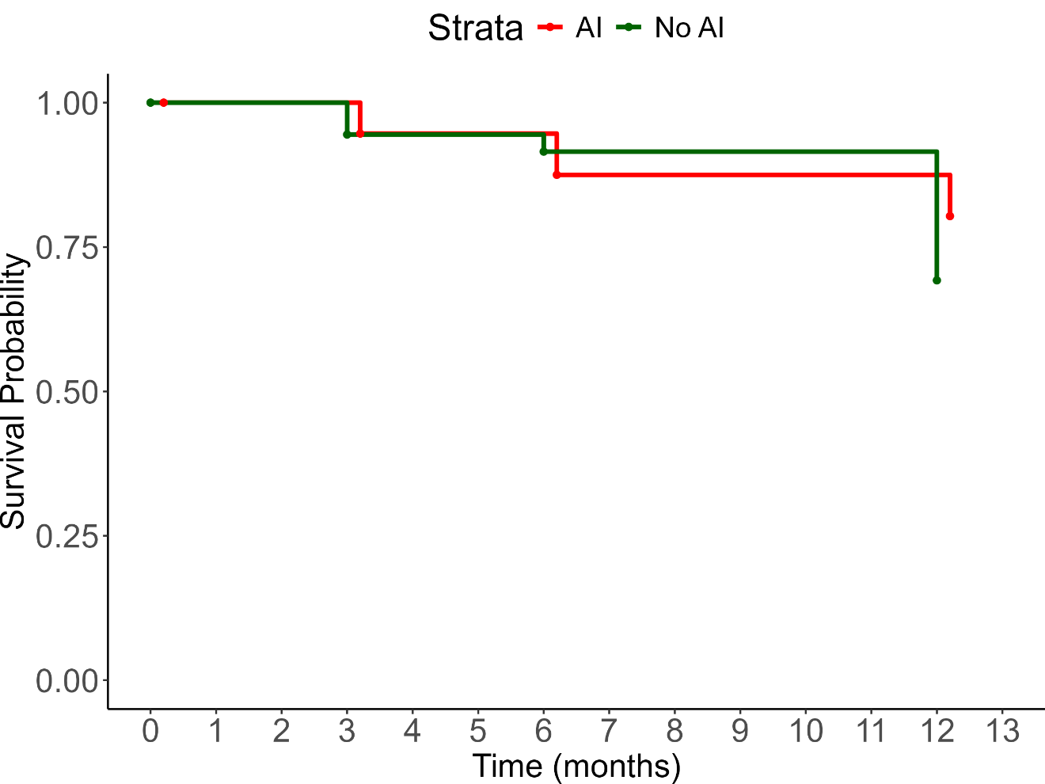
Fig 2: The Kaplan-Meier survival curves for patients with adrenal insufficiency (AI) compared with those without (No-AI) among HIV positive patients with a CD4 count less than 100 cells per mm3

Table 4: Comparisons of the clinical characteristics of patients who died with AI versus those without
Variable | AI, N = 111 | Non-AI, N =  1561 | p-value2
Age at enrolment, median (IQR)  (years) | 41 (37, 48) | 37 (30, 44) | 0.13
Female gender, N(%) | 6 (54.5%) | 83 (53.2%) | >0.9
Duration of current illness, median  (IQR) (days) | 14 (10, 14) | 14 (14, 21) | 0.2
HISTORY
Weight loss | 9 (81.8%) | 129 (89.0%) | 0.6
Weakness | 9 (81.8%) | 127 (87.6%) | 0.6
Tiredness | 11 (100.0%) | 128 (88.9%) | 0.6
Poor appetite | 11 (100.0%) | 119 (82.1%) | 0.2
Increased pigmentation of the skin | 4 (44.4%) | 83 (58.5%) | 0.5
Nausea | 9 (81.8%) | 84 (57.9%) | 0.2
Loss of consciousness | 0 (0.0%) | 4 (2.7%) | >0.9
Diarrhea | 3 (27.3%) | 71 (49.0%) | 0.2
Dizziness | 5 (45.5%) | 73 (50.7%) | 0.7
Shock | 0 (0.0%) | 2 (1.4%) | >0.9
Anorexia | 4 (36.4%) | 73 (50.7%) | 0.4
Loss of axillary and pubic hair, if  female | 2 (18.2%) | 35 (23.6%) | 0.8
CLINICAL FEATURES
BP (systolic) mmHg | 127 (114, 129) | 110 (100, 124) | 0.11
BP (diastolic) mmHg | 79 (67, 83) | 70 (60, 80) | 0.2
Heart rate beats per minute | 82 (70, 103) | 92 (79, 108) | 0.3
Hypotension | 0 (0.0%) | 16 (11.0%) | 0.6
Any postural drop in blood pressure | 0 (0.0%) | 7 (4.9%) | >0.9
Presence of anaemia | 6 (54.5%) | 93 (64.6%) | 0.5
INVESTIGATIONS
Sodium mmol/L | 134 (132, 139) | 133 (129, 137) | 0.11
Potassium mmol/L | 3.90 (3.65,  4.65) | 4.00 (3.50,  4.60) | >0.9
Haemoglobin g/dL | 8.70 (7.45,  10.45) | 8.40 (7.10,  9.60) | 0.5
Syphilis | 0 (0.0%) | 4 (2.6%) | >0.9
Candida | 1 (9.1%) | 7 (4.6%) | 0.4
Hepatitis B | 1 (9.1%) | 5 (3.3%) | 0.3
Herpes simplex virus HSV | 0 (0.0%) | 2 (1.3%) | >0.9
Pneumonia | 0 (0.0%) | 14 (9.2%) | 0.6
Pneumocystis Jiroveci Pneumonia | 0 (0.0%) | 2 (1.3%) | >0.9
Pulmonary tuberculosis | 5 (45.5%) | 101 (66.4%) | 0.2
Extrapulmonary tuberculosis | 4 (36.4%) | 28 (18.4%) | 0.2
Cryptococcus neoformans | 5 (45.5%) | 7 (4.6%) | <0.001
Total CD4 count cells/ mm3 | 43 (17, 67) | 28 (12, 57) | 0.3
Viral load (log10 copies/mL) | 12.3 (12.3,  12.3) | 11.6 (7.6,  13.0) | 0.8
Random cortisol nmol/L | 281 (244, 341) | 519 (418, 640) | <0.001
Basal cortisol nmol/L | 284 (201, 365) | 484 (411, 625) | <0.001
Stimulated cortisol nmol/L | 375 (321, 426) | 791 (627, 916) | <0.001
Absolute delta cortisol | 32 (17, 107) | 263 (179,360) | <0.001
Percentage change in cortisol levels* | 12 (10, 42) | 51 (37, 73) | 0.033
¹Median (IQR); n (%); ²Wilcoxon rank sum test; Pearson’s Chi-squared test; Wilcoxon rank sum exact test;
Fisher’s exact test
*Difference in the basal, compared to the stimulated cortisol, expressed as a percentage basal cortisol p-value is a comparison of clinical characteristics of patients with AI versus those without AI, among all those who had died

Predictors of mortality:
Mortality was associated with the presence of skin pigmentation (51%) and poor appetite (77%), increased random cortisol, and ACTH. Opiate use appeared to be associated with survival at 12 months. A logistic regression analysis was undertaken. (Table 5) For every 50 nmol/L increase in the basal cortisol, there was associated 14% increase in the likelihood of death within 12 months (OR = 1.14, (95%CI:1.08, 1.21); p<0.001). In contrast, opiate use was associated with a 45% reduction in the likelihood of death [OR = 0.55, (95%CI: 0.0.33, 0.87)]; p=0.013. For every 100 pg/L increase in the plasma ACTH, a 17% increase in the likelihood of death was observed (OR = 2.17, (95%CI:1.35, 3.72); p<0.003). Patients with a self-reported increased skin pigmentation had a 51% increase in the odds of mortality (OR = 1.51 (95%CI: 1.03, 2.22) but this was not exclusively the result of primary hypoadrenalism p=0.033). The presence of a poor appetite was associated with a 77% likelihood of premature death [OR=1.77 (95%CI: 1.11, 2.90); p=0.020)].
After adjusting for several factors, as shown in Table 5, the only features which were independently associated with premature mortality were decrease in systolic, increased diastolic blood pressures, increased random cortisol and opiate use. Every 10 mmHg increase in diastolic blood pressure was associated with a 30% increase in likelihood of premature mortality (aOR = 1.30 (95%CI: 1.07, 1.59), p=0.01). Every 10 mmHg increase in systolic blood pressure was associated with an 18% reduction in the odds of mortality (aOR = 0.82 (95%CI: 0.71, 0.95) p=0.010). Every 50 nmol/L increase in random cortisol was associated with a 14.7% likelihood of premature death (aOR = 1.147 (95%CI:1.082, 1.217) p<0.001). While opiate use was associated with a 44.5% reduction in the odds of mortality (aOR = 0.555 (95%CI:0.33, 0.933), p=0.026).

Table 5: Bivariate and Multivariate analysis of factors associated with time to mortality of patients in the entire cohort.
Characteristic | N | Bivariate |  |  |  | Multivariable
Characteristic | N | OR1 | 95% CI1 | p-value | Adj. OR3 (95% CI)1 |  | p-value
History
Increased skin pigmentation | 525 | 1.51 | 1.03,  2.22 | 0.033 | 1.26 (0.76, 2.08) |  | 0.379
Poor appetite | 535 | 1.77 | 1.11,  2.90 | 0.02 | 1.25 (0.72, 2.19) |  | 0.425
Liking for salt | 536 | 1.33 | 0.92,  1.95 | 0.13 | 1.27 (0.85, 1.90) |  | 0.244
Nausea | 538 | 1.4 | 0.96,  2.05 | 0.08 | 1.08 (0.66, 1.78) |  | 0.754
Blood pressure_systolic | 553 | 0.93 | 0.84,  1.03 | 0.2 | 0.82 (0.71, 0.95) |  | 0.010
Blood pressure_diastolic | 553 | 1.13 | 0.98,  1.30 | 0.088 | 1.30 (1.07, 1.59) |  | 0.010
Investigations
Haemoglobin (Drop) | 558 | 0.92 | 0.85,  1.00 | 0.06 | 0.93 (0.85, 1.02) |  | 0.138
Clostridium difficile | 549 | 0.49 | 0.14,  1.32 | 0.2 | 0.61 (0.19, 1.91) |  | 0.394
Increased Random cortisol | 548 | 1.14 | 1.08,  1.21 | <0.001 | 1.15 (1.08, 1.22) |  | <0.001
Basal_cortisol | 167 | 1.06 | 0.98,  1.15 | 0.13
Increased ACTH | 548 | 2.17 | 1.35,  3.72 | 0.003 | 1.25 (0.95, 1.65) |  | 0.115
Cryptococcus_neoformans | 549 | 1.72 | 0.79,  3.67 | 0.2 | 1.77 (0.71, 4.40) |  | 0.217
Pneumonia | 549 | 0.66 | 0.34,  1.21 | 0.2 | 0.68 (0.35, 1.34) |  | 0.269
CD4 count | 557 | 0.77 | 0.56, | 0.11 | 1.02 (0.70, 1.47) |  | 0.935
Viral load | 126 | 1.08 | 0.98,  1.21 | 0.14 | 1.02 (0.95, 1.10) |  | 0.554
Medications
Opiate use | 563 | 0.55 | 0.33,  0.87 | 0.013 | 0.56 (0.33, 0.93) |  | 0.026
Fluconazole | 563 | 1.64 | 0.98,  2.71 | 0.056 | 1.61 (0.90, 2.87) |  | 0.108
¹Odds Ratio; ²95% Confidence interval; ³Adjusted Odds Ratio, ACTH Adrenocorticotrophin hormone, Hb haemoglobin, VL Viral load.

Results of the A.I. method for predicting AI:
The single best-performing model demonstrated excellent predictive capability on the unseen test data. It achieved a test sensitivity of 90.9% and a test specificity of 87.3%. The confusion matrix for this model (Figure 3) shows that it correctly identified 10 of the 11 patients with adrenal insufficiency. The model's overall discriminative power is further illustrated by its Receiver Operating Characteristic (ROC) curve (Figure 4), which yielded an Area Under the Curve (AUC) of 0.885, indicating a high degree of separability between the positive and negative classes.
To ensure our feature importance analysis was not biased by a single training run, we aggregated the results from the top 10 performing models. Figure 5 presents the mean relative importance and standard deviation for each feature across this ensemble of high-performing models. This aggregated analysis reveals a more distributed and nuanced predictive landscape.
While Random cortisol result remains the single most predictive feature, its relative importance of approximately 14% suggests that while it is the primary indicator, a constellation of other clinical and demographic factors is crucial for achieving high accuracy. The second most important predictor was Ethnicity, highlighting a significant demographic component in the model's decision-making. The use of Fluconazole, along with clinical symptoms like Dizziness and Weight loss, were also identified as highly influential. The error bars in the plot, representing the standard deviation of importance across the top models, indicate that the high ranking of these top-tier features was consistent, underscoring their reliability as predictors.
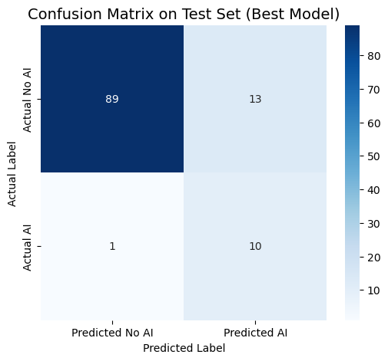

Fig 3: Confusion matrix on test set
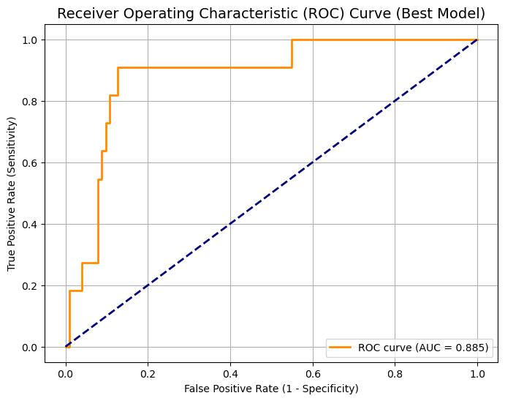

Fig 4: Receiver operating characteristic curve representing the sensitivity & specificity of A.I. for AI prediction
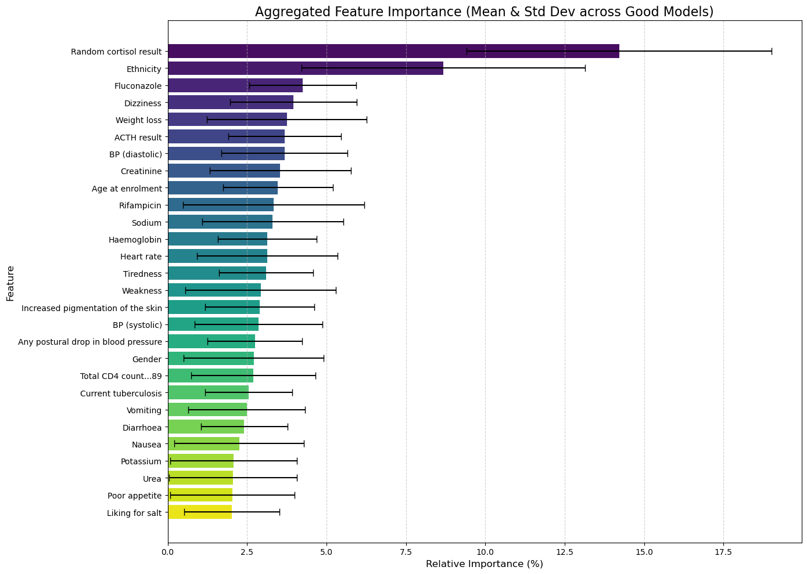
Fig 5: Features predictive of AI in order of importance.

Discussion:
VERSION 1
- Overall, in this cohort, the youngest group had the lowest CD4 counts.
- The prevalence of Candida albicans was highest in the lowest tertile CD4 counts.
- Patients with the highest viral load also had the lowest white cell counts, lymphocytes and neutrophils.
- Patients with AI had significantly higher incidence of extrapulmonary tuberculosis and Cryptococcus infection and higher serum sodium concentrations.
- Haemoglobin concentrations were found to be greater and fluconazole use was higher in the AI compared with the non-AI groups.
- The prevalence of Cryptococcal neoformans was associated with mortality in the AI group.
- Lower random, basal, stimulated, incremental, and Dr cortisol concentrations were associated with higher mortality in the adrenal insufficiency group.
- There was significantly higher mortality at 12 months follow up in the group without adrenal insufficiency compared with AI.
- Skin Pigmentation and poor appetite were associated with increased mortality.
- Increased cortisol and ACTH were associated with increased risk of death, whereas opiate use appeared to be protective.
- Reduced systolic and diastolic blood pressures, elevated random cortisol and opiate use were independently associated with 12-month mortality.
- Patients with AI improved survival at 12 months, compared with those without.
- There was a borderline difference in the AI mortality of 19.6% in contrast with 31.7% in those without AI (p=0.06)

VERSION 2

Our data represents an incidence of adrenal insufficiency of 9.95% in patients with advanced HIV who presented with an opportunistic infection. Overall, in this cohort, the youngest group had the lowest CD4 counts. The prevalence of candida was highest in lowest CD4 count tertile. Patients with the highest viral load also had the lowest white cell counts, lymphocytes and neutrophils. Patients with AI had significantly higher incidence of extrapulmonary tuberculosis and Cryptococcus infection and higher serum sodium concentrations. The presence of high viral load which is accompanied by low CD4 counts, white cell counts, lymphocytes and neutrophil counts was associated with known causes of adrenal insufficiency such as EPTB and Cryptococcus which predominated in this cohort. Although we cannot prove causality, there was a strong association between these two opportunistic infections and mortality in the AI group, compared to the group with AI. It is a well known fact that undiagnosed and untreated AI carries significant mortality, and it is possible that we can mitigate against this possibility by viewing the co-infection with these terrible twins in advanced HIV as AI-defining illnesses which would trigger a cortisol screening test to facilitate early diagnosis and intervention. This is premised on the established clinical practice of automatic screening for cryptococcus in HIV positive patients admitted with CD4 counts less than 100 cells/mm³.

Other positive findings included greater heamoglobin concentrations and higher fluconazole use in the AI compared to the non-AI groups. There was significantly higher mortality at 12 months follow up in the group without adrenal insufficiency compared with AI. Reduced systolic and diastolic blood pressures, elevated random cortisol and opiate use were independently associated with 12-month mortality. Skin Pigmentation and poor appetite, lower random, basal, stimulated, incremental, and delta cortisol concentrations were associated with higher mortality in the adrenal insufficiency group. Patients with AI improved survival at 12 months, compared with those without. This suggests that AI patients may have benefited from admission with cortisol screening, early AI diagnosis, appropriate intervention and followup, further emphasizing the need to embark upon a concerted, global, including the WHO LMIC awareness campaign to raise AI-awareness, especially in patients with advanced HIV presenting with the terrible twins in EPTB & Cryptoccal neoformans. This mortality advantage further suggests possible reversibility of HIV associated AI (HIVAAI), thus making cortisol screening, diagnosis and treatment a worthwhile investment in high risk patients as decribed above.

Comparison with other studies:
In a study by X 16.6% of people with HIV had significantly lower cortisol in contrast to our patients 9.95%who also had HIV. There is a wide range of AI prevalences in patients with AIDS, and in contrast to our study prevalence of 9,95%, a study by Prasanthai et al revealed of prevalence of 19.2% in a relatively small study involving 26 patients. They also recommended that adrenal testing should be perfomed on all hospitalized patients with AIDS in critical and non-critical illness.

VERSION 3:

Adrenal insufficiency prevalence and demographics
Our study identified AI in 9.5 % of advanced HIV patients bracket CD 4 less than 100, consistent with prior reports ranging from 5 to 20% in similar cohorts (Elliot at all, 2015 Mayo et all, 2002). The variability may reflect the difference in diagnostic criteria edging ACTH stimulation versus basal cortisol population characteristics searches opportunistic infection burden. Notably, our cohort’s younger age group was associated with the lowest CD4 counts.

OI:
AI patients had higher rates of extra pulmonary TB and cryptococcosis, aligning with studies demonstrating adrenal involvement in disseminated infections (Jarvis at al 2013, Tsang at al., 2020). For example Javis et al., 2013 reported adrenal Cryptococcus infiltration in 40% of autopsies in advanced HIV. The association between Cryptococcus neoformans and mortality in our AI group parallels findings from Bicanic at al., 2009, where the cryptococcal meningitis mortality exceeded 50% in patients with CD4 less than 100.

Lab:
Low CD4/high viral load:
The link between leucopaenia (lymphopenia, neutropenia) and high viral loads replicates results from the INSIGHT SMART trial (El-Sadr et al ., 2006, which tied uncontrolled viremia to bone marrow suppression.

Hypontraemia vs Hyponatraemia:
Elevated sodium in our AI patients contrast with classic adrenal crisis hyponatremia but matches the reports of mineralocorticoid deficiency in chronic HIV associated AI (Eledrisi and Verghese, 2001).

Mortality paradox:
Despite higher ROI's, AI patients had lower 12 months mortality (19.6% vs 31.7%, p=0.06). This mirrors the cohere call hot(Sabin et al., 2014), Where glucocorticoid replacement in AI improved survival. However, other studies egg marik et al ., 2008 Caution against over replacement due to infection risk highlighting a need for tailored therapy.

Cortisol and Mortality:
The dual observation of low cortisol predicting AI related death and elevated cortisol stress marker aligns with Andersen et al., (2020), who proposed a U-shaped mortality risk: suggesting that both adrenal failure and excessive stress responses worsen outcomes.

Comparative analysis:

Findings | Our study | Comparator | Implications
AI Prevalence | 9.95% | 5-20% (Elliot et al., 2015; Mayo et al., 2002 | Supports screening in advanced HIV
Cryptococcus-mortality | Strong in AI | 50% mortality in CD4<100 (Bicanic et al., 2009) | Reinforces need for early antifungal therapy.
Survival paradox | AI survival benefit (p=0.0 | COHERE: GCs improve survival (Sabin et al., 2014) | Suggest AI management gaps in non-AI patients
Cortisol mortality | Low and high cortisol risky | U-shaped risk (Andersen et al ., 2020) | Advocates for dynamic cortisol monitoring

Use of A.I. in AI prediction:
This study successfully developed and validated a neural network model that can predict adrenal insufficiency with high sensitivity and strong overall accuracy. The key contribution of this work lies in its rigorous methodology, which combined L1 regularization with an aggregated analysis across multiple training runs to produce a stable and reliable understanding of the factors driving the prediction.

Our findings confirm the central role of cortisol levels but also elevate the importance of other, less traditional factors such as patient ethnicity and the use of specific medications like Fluconazole. This suggests that the interplay of demographic, clinical, and laboratory data is complex and that a multivariate approach is essential for accurate prediction. This machine learning model represents a promising step towards creating a reliable, data-driven tool to assist clinicians in the early identification of patients at high risk for adrenal insufficiency, and the feature importance analysis provides valuable directions for future clinical research.

Strengths :
This is the biggest study on patients with advanced HIV Africa confirming AI, its associated co-infections EPTB & Cryptococcus which strongly suggest screening for cortisol in patients admitted with this terrible triad.

The weaknesses
A small AI sample size.
Telephonic and clinic follow up to check post discharge mortality.
It is a single center study and may thus its findings may not be generalizable. Unavailability of the LC/MS which is the new GOLD Standard for steroid analysis.

Future directions:
- Investigate the mechanism of the AI survival paradox, including possible glucocorticoid immunomodulation.
- Exploration of thresholds for mortality risk stratification.

Conclusion:
The largest African study on hypoadrenalism in advanced HIV revealed the AI incidence of 9.95% and overall mortality of 26.9%. We feel that screening for AI is warranted in advanced HIV, to mitigate the risk of death. The majority of the opportunistic infections were tuberculosis, pneumonia and cryptococcal infections. Extra- pulmonary tuberculosis and cryptococcal infections correlated with the aetiology of mortality in patients with AI and may be AI-defining illnesses in advanced HIV, while elevated cortisol was associated with increased odds of death.

Uncategorized References

- Dunlop D. Eight-six cases of Addison's disease. British medical journal. 1963;2(5362):887.
- Betterle C, Morlin L. Autoimmune Addison’s disease. Pediatric adrenal diseases. 2011;20:161-72.
- Ross IL, Levitt NS. Addison’s disease symptoms–a cross sectional study in urban South Africa. PLoS One. 2013;8(1):e53526.
- Mofokeng TR, Beshyah SA, Mahomed F, Ndlovu KC, Ross IL. Significant barriers to diagnosis and management of adrenal insufficiency in Africa. Endocrine connections. 2020;9(5):445- 56.
- Mofokeng TRP, Ndlovu KCZ, Beshyah SA, Ross IL. Tiered healthcare in South Africa exposes deficiencies in management and more patients with infectious etiology of primary adrenal insufficiency. Plos one. 2020;15(11):e0241845.
- Goliber T. The status of the HIV/AIDS epidemic in Sub-Saharan Africa. Population Reference Bureau. 2002.
- Hofbauer LC, Heufelder AE. Endocrine implications of human immunodeficiency virus infection. Medicine. 1996;75(5):262-78.
- Boulle A, Schomaker M, May MT, Hogg RS, Shepherd BE, Monge S, et al. Mortality in patients with HIV-1 infection starting antiretroviral therapy in South Africa, Europe, or North America: a collaborative analysis of prospective studies. PLoS medicine. 2014;11(9):e1001718.
- Arlt W. Adrenal insufficiency. Clinical medicine. 2008;8(2):211.
- Husebye ES, Pearce SH, Krone NP, Kämpe O. Adrenal insufficiency. The Lancet. 2021;397(10274):613-29.
- Eledrisi MS, Verghese AC. Adrenal insufficiency in HIV infection: a review and recommendations. The American journal of the medical sciences. 2001;321(2):137-44.
- Bornstein SR. Predisposing factors for adrenal insufficiency. New England Journal of Medicine. 2009;360(22):2328-39.
- Afreen B, Khan KA, Riaz A. Adrenal insufficiency in Pakistani HIV infected patients. Journal of Ayub Medical College Abbottabad. 2017;29(3):428-31.
- Odeniyi I, Fasanmade O, Ajala M, Ohwovoriole A. Adrenocortical function in Nigerians with human immunodeficiency virus infection. Ghana Medical Journal. 2013;47(4):171.
- Bergthorsdottir R, Leonsson-Zachrisson M, Odén A, Johannsson G. Premature mortality in patients with Addison’s disease: a population-based study. The Journal of Clinical Endocrinology & Metabolism. 2006;91(12):4849-53.
- Johannsson G, Falorni A, Skrtic S, Lennernäs H, Quinkler M, Monson JP, et al. Adrenal insufficiency: review of clinical outcomes with current glucocorticoid replacement therapy. Clinical endocrinology. 2015;82(1):2-11.
- Vogeser M, Kratzsch J, Ju Bae Y, Bruegel M, Ceglarek U, Fiers T, et al. Multicenter performance evaluation of a second generation cortisol assay. Clinical Chemistry and Laboratory Medicine (CCLM). 2017;55(6):826-35.
- Holst JP, Soldin SJ, Tractenberg RE, Guo T, Kundra P, Verbalis JG, et al. Use of steroid profiles in determining the cause of adrenal insufficiency. Steroids. 2007;72(1):71-84.
- Bancos I, Hazeldine J, Chortis V, Hampson P, Taylor AE, Lord JM, et al. Primary adrenal insufficiency is associated with impaired natural killer cell function: a potential link to increased mortality. European journal of endocrinology. 2017;176(4):471-80.
- Christ-Crain M, Stolz D, Jutla S, Couppis O, Müller C, Bingisser R, et al. Free and total cortisol levels as predictors of severity and outcome in community-acquired pneumonia. American journal of respiratory and critical care medicine. 2007;176(9):913-20.

Reducing the risk of adrenal crises: a service improvement project assessing education on adrenal insufficiency
Kirsty Elliot, Catriona Don, Jill Gibb, Nicholas Conway

Adrenal Function in the Human Immunodeficiency Virus–Infected Patient
Jose Mayo, MD; Julio Collazos, MD; Eduardo Martínez, MD; et al

Relationship of cerebrospinal fluid pressure, fungal burden and outcome in patients with cryptococcal meningitis undergoing serial lumbar punctures
Bicanic, Tihana^{a,b,c}; Brouwer, Annemarie E^{b,e,h}; Meintjes, Graeme^{c,d}; Rebe, Kevin^{c,d}; Limmathurotsakul, Direk^{e}; Chierakul, Wirongrong^{e}; Teparrakkul, Praprit^{f}; Loyse, Angela^{a,b,c}; White, Nicholas J^{e,g}; Wood, Robinª; Jaffar, Shabbar^{i}; Harrison, Thomas

